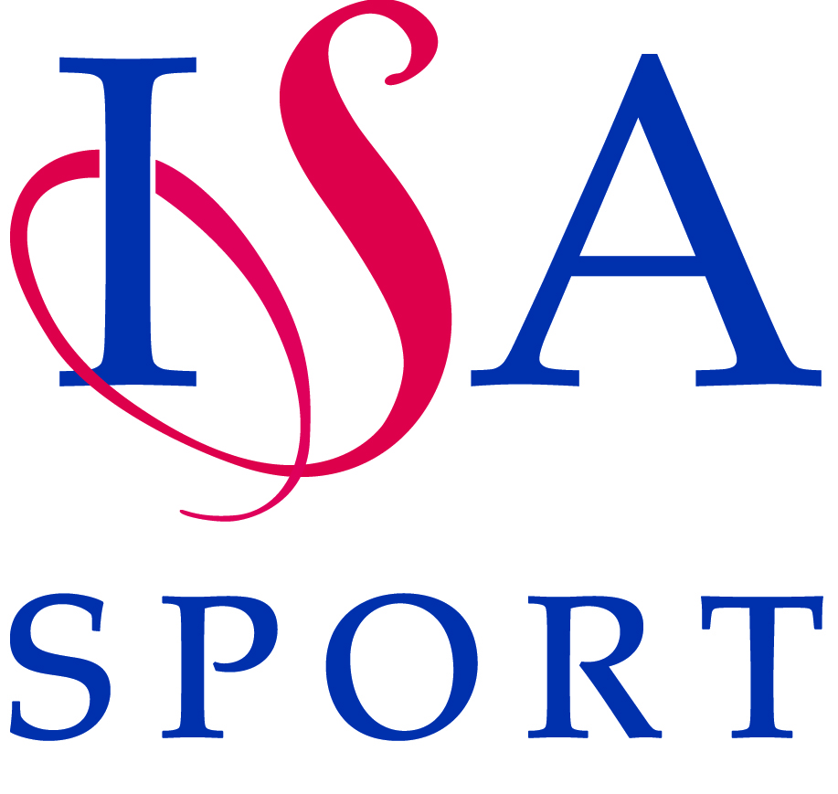

NATIONAL SPORTS EVENTS - RISK ASSESSMENT FORM

Activity/ Event: Event Date:

Organiser: Area:

Venue & Address:

Identify the Hazard  List significant hazards which may result in serious harm | Assess the Risk  List who may be harmed and how seriously | Evaluate the Risk  How likely is it that the hazard could cause harm? List any existing controls | List Further Action  List proposed action and the person responsible for it

Signed: Print Name: Date Signed:

Please attach the liability insurance certificate along with this risk assessment form as specified below and tick the box to confirm that you have done this.

Liability Insurance | Please tick to confirm
I have checked and ensured that the venue for this event has the correct Liability Insurance and a copy of the certificate is also attached. (I am aware that a copy of the school’s liability insurance certificate will be required if an event is held at a school).

